CSA1717-ARTIFICIAL INTELLIGENCE
PRACTICAL LAB EXPERIMENTS
NIHARIKA PREEJESH (192524506)

PROGRAM 18: TOWER OF HANOI PROBLEM
Aim:
To solve the Tower of Hanoi problem using recursion.
Objective:
- To move all disks from the source rod to the destination rod.
- To follow the rules of the Tower of Hanoi.
- To minimize the number of moves.
Algorithm:
- Read the number of disks.
- Move n−1 disks from source to auxiliary.
- Move the largest disk to destination.
- Move n−1 disks from auxiliary to destination.
- Repeat recursively until all disks are moved.
- Display each move.
Flowchart:
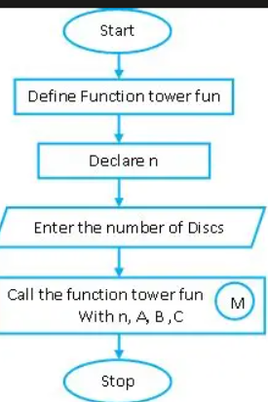

Python Code:
def tower(n, source, auxiliary, destination):

if n == 1:
print("Move Disk 1 from", source, "to", destination)
return

tower(n - 1, source, destination, auxiliary)

print("Move Disk", n, "from", source, "to", destination)

tower(n - 1, auxiliary, source, destination)

n = int(input("Enter Number of Disks: "))

tower(n, 'A', 'B', 'C')
Sample Input
3
Sample Output
Move Disk 1 from A to C
Move Disk 2 from A to B
Move Disk 1 from C to B
Move Disk 3 from A to C
Move Disk 1 from B to A
Move Disk 2 from B to CMove Disk 1 from A to C
Output:
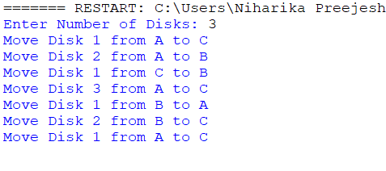
Result:
Tower of Hanoi problem was successfully implemented.

